COMP 9900 Information Technology project 2023 T2

Retrospective B

Assessment

Group: 9900F15APT5D

**Yue Niu (Scrum Master)**

Front-end/Back-end z5356976 z5356976@ad.unsw.edu.au

**Haoxian Zhang**

Back-end z5327309 z5327309@ad.unsw.edu.au

**Lichen Zhang**

Front-end z5373704 z5373704@ad.unsw.edu.au

**Zhourui Shi**

Front-end z5348712 z5348712@ad.unsw.edu.au

**Yimin Liu**

Back-end z5228038 z5228038@ad.unsw.edu.au

Meeting Date: 20/07/2023

Meeting Time: 17:00 PM

Submission Date: 20/07/2023, 10:30 PM

Attendees: All team members are present at the Retrospective A meeting.

## Section1: What went well

1.1 In this section, firstly we finished our 17 user story at below in Figure 1.

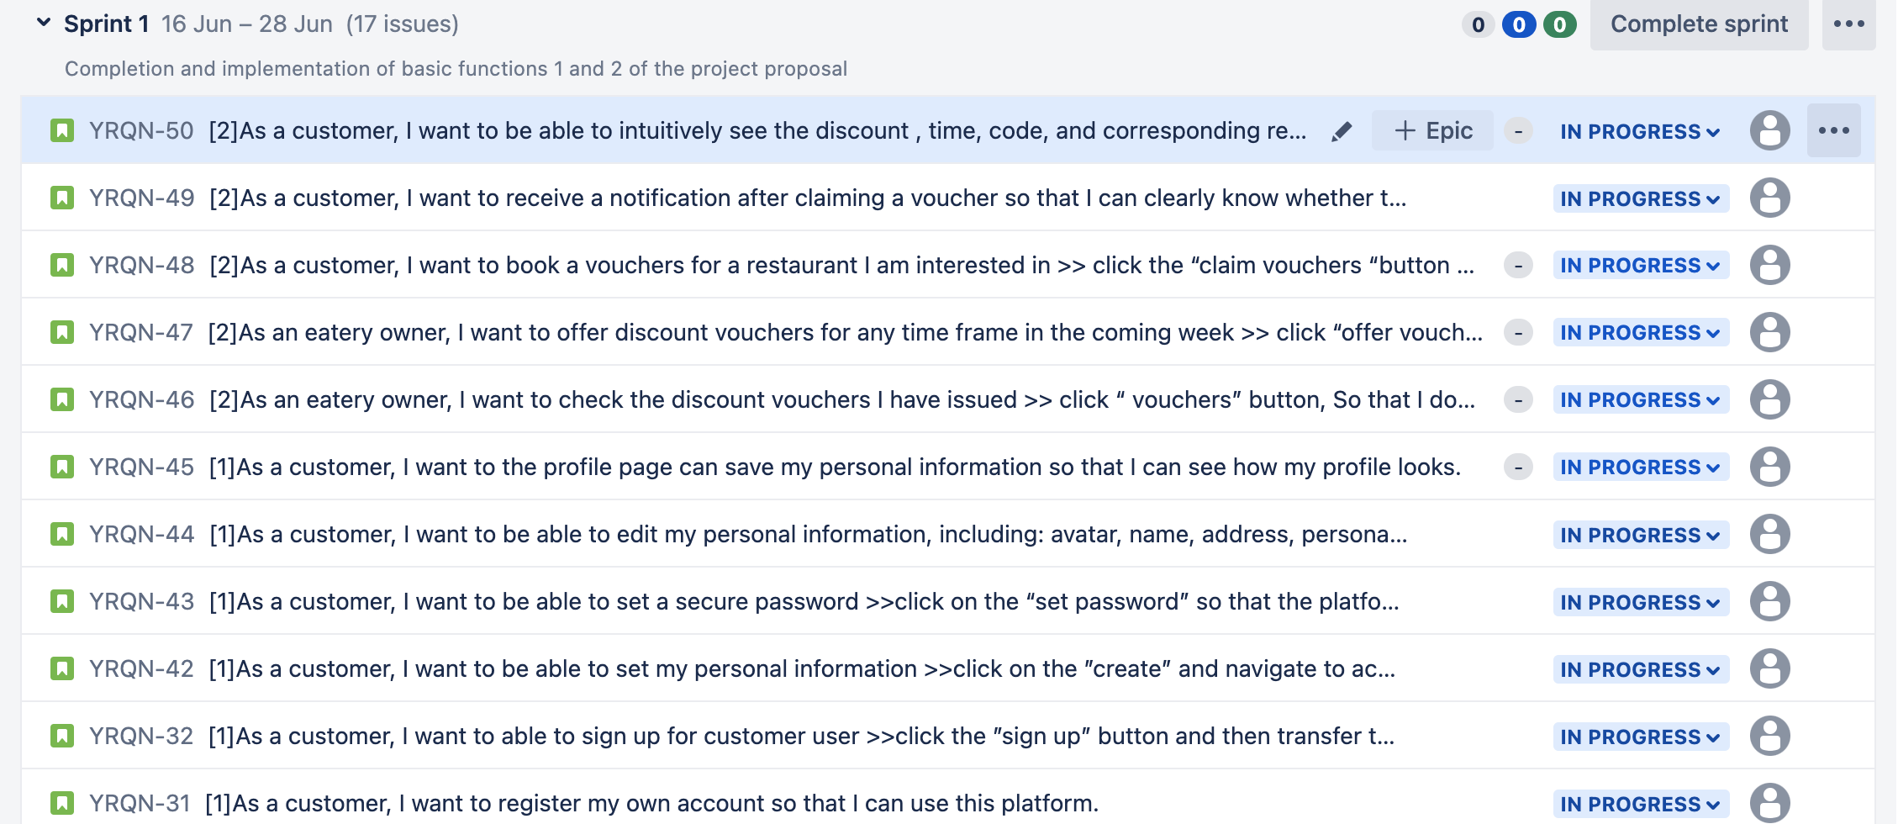

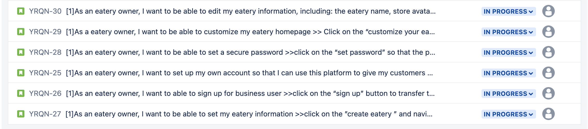

Figure 1 User stories of sprint 2 in Jira.

1.2 Our project purpose on Demo B

In the implementation of function3, 4, and 5 this time, we will mainly carry out the following steps:

First, restaurants can set up and issue vouchers, which customers can collect and book.

Secondly, customers can successfully use it in the restaurant after receiving the voucher. The restaurant will check the code on the voucher and provide feedback accordingly.

Finally, customers can check other customers' comments and ratings on the business before dining, so as to consider whether to choose the restaurant for dining. At the same time, after the meal, customers can also provide their own real evaluation, so that the merchant can improve the problem in time.

1.3 During the voucher type :

We have two types of voucher settings, namely normal type and weekly type. Our main function is to simplify the voucher setting interface and make the operation easier, so that users can directly select different voucher types on the setting page without cumbersome steps.

Finally, we also classify the normal and weekly vouchers to ensure that the management of vouchers will not be confusing, so that users can easily find the vouchers they need, which improves the user experience.

1.4 Our database design is characterized by its convenience, no redundancy, no waste of memory, and quick addition, deletion, query and modification.

1.5 The front-end framework is relatively clear, the branch of each function is clear and the code is not streamlined.

1.6 API-Managing the eatery and customer user classes using the blueprint module to ensure clear and concise code for easy management and future development.

1.7 Improve what we did not done well in Demo A

|  |  |
| --- | --- |
| What we did not done well | Improve process |
| The front end and back end are not fully connected, such as the profile page. | we made the following changes:  First, API data integration: API documents will be planned by function, which is easy to find. We will store the records of the documents in real time, and require that the annotations of the API must be clear and clear to facilitate front-end and back-end interactions.  Second, real-time communication  We have formulated a plan for regular communication, which can be attended both online and offline to ensure that both front-end and back-end personnel participate in the meeting. The conference internal communication is updated in real time, and the main direction is to answer the problems that arise in the front-end and back-end and discuss together any functions that can be realized and cannot be realized during the project development process.  Third, the formulation of front-end and back-end data formats  Backend use: flask  Front-end use: react  The data structure is: formdata |
| Our function is not connected to Jira. | In this problem, we assign different function modules to the front-end and back-end personnel. First, write the user stories of different functions. Secondly, in the process of realizing the functions, we will continue to improve. Within the specified time, the team members will update their tasks to jira synchronously middle. Finally in retrospective A the project follower we make will check the progress regularly. |
| Did not prepare according to the rules of demoA. | In this problem, in the process of realizing the functions in DemoB, we check the demonstration requirements formulated by DemoB in real time, and rehearse before the project demonstration |

## Section2: What did not go so well

2.1

## Section3: What Things to try in the next sprint to improve the team's work process

3.1 The things we want to try on sprint 3 show below in Figure 2.

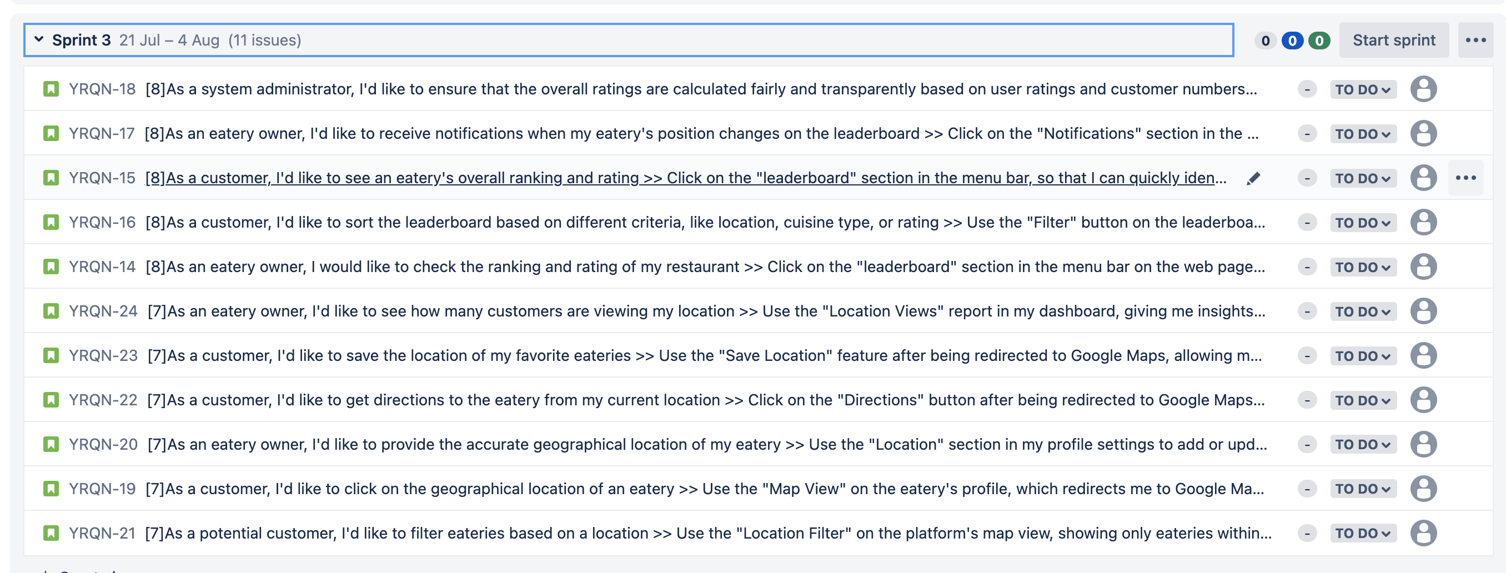

Figure 2 User stories of sprint 2 in Jira.

**Plan:**

Our sprit3 are still in progress, so we first assign the 11 user stories in our sprint3 to team members, then subdivide and plan the user stories according to the next four functions, and upload them to Jira on time.

User story: YQRN 14-16 Yue Niu.

User story: YQRN 17-18 Zhourui Shi

User story: YQRN 19-20 Licheng Zhang

User story: YQRN 21-22 Yiming Liu

User story: YQRN 23-24 Haoxian Zhang

**Reflecting on our teamwork processes in the next sprit3**

|  |  |
| --- | --- |
| Reflection 1 | Make sure that every team member takes the initiative and participates in every team discussion, asks questions, communicates problems, and solves problems. |
| Reflection 2 | Team members have a clear division of tasks to ensure that tasks are completed on time and efficiently. |
| Reflection 3 | The project follow-up personnel should give timely feedback on the follow-up situation and problems, and make timely improvements. |
| Reflection 4 | Set priorities in team projects to avoid conflicts between primary and secondary functionality. |

**To try list for the member who attempting to enforce or follow up on each item:**

|  |  |
| --- | --- |
| Item | assigned member |
| Check and run the front-end and back-end codes, communicate and solve problems in a timely manner. | Haoxian Zhang |
| Determine when each project starts and finishes. Communicate in a timely manner during the completion of the project to ensure that the project will not be delayed. | Yue Niu |
| Overall visual design of the project | Zhourui Shi |